Name = Krish
Roll Number = 2401010177
- Create a database Car_Rentals.
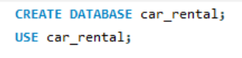
- Create Table customers for add customers details .
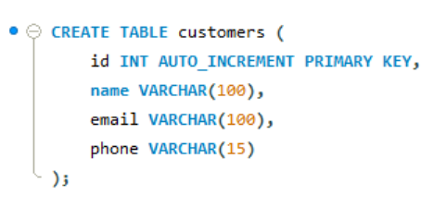
- Create Table cars that take car details .
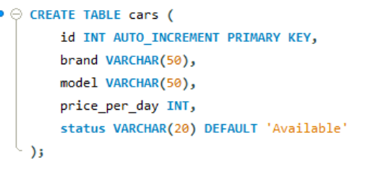
- Create table Renatls for adding which take car in which and return in which date
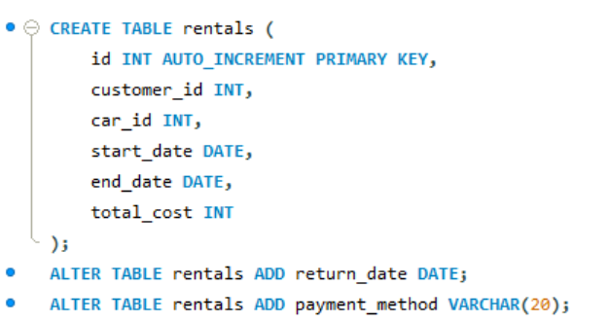

- Add pre details in car .
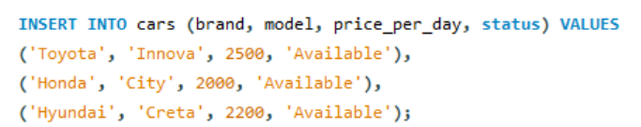
- Select * From Customers that we add customers in portfolio.

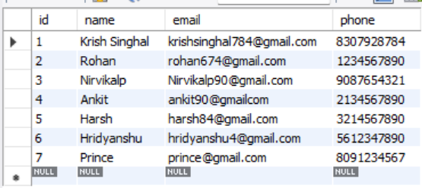

- Select * from cars for see which car added in cars .
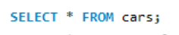
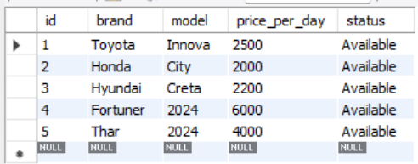
- Select * from Rentals for see which customer take which car for rent for how much time and and what rent .
